**Lab-6: Active filters using op-amps**



In this lab, we implement low-pass and bandpass resonant filters using op-amp active filters. Objectives are:

1. Introduction to active filter design and its advantages.
2. Implementation of active filters and introduction to Sallen-Key filter topology.

**Step-0: a crash course on active-filters**

So far in the course, we have learned how to analyze the various configuration of RC, RL, and RLC passive filters. However, there are other ways to build filters. Active filters are a type of filter that includes an amplifier (typically an op-amp) in their filter design. Including an op-amp in the design not only solves the loading effects by providing high input impedance and low output impedance, it also gives you a completely new design space to create a variety of transfer functions and filters. Let's go through a few examples to see this:

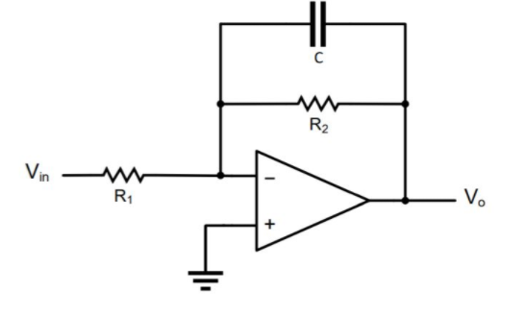

Figure.1. RC active filter

In the first example, we have an op-amp with a resistor and a capacitor in the negative feedback loop. Using op-amp rules, we can solve for transfer function (Vo/Vin) as follows:

Ink Drawings
Ink Drawings
Ink Drawings
Ink Drawings
Ink Drawings
Ink Drawings
Ink Drawings
Ink Drawings
Ink Drawings
Ink Drawings
Ink Drawings
Ink Drawings
Ink Drawings
Ink Drawings
Ink Drawings
Ink Drawings
Ink Drawings
Ink Drawings
Ink Drawings
Ink Drawings
Ink Drawings
Ink Drawings
Ink Drawings
Ink Drawings
Ink Drawings
Ink Drawings
Ink Drawings
Ink Drawings
Ink Drawings
Ink Drawings
Ink Drawings
Ink Drawings
Ink Drawings
Ink Drawings
Ink Drawings
Ink Drawings
Ink Drawings
Ink Drawings
Ink Drawings
Ink Drawings
Ink Drawings
Ink Drawings
Ink Drawings
Ink Drawings
Ink Drawings
Ink Drawings
Ink Drawings
Ink Drawings
Ink Drawings
Ink Drawings
Ink Drawings
Ink Drawings
Ink Drawings
Ink Drawings
Ink Drawings
Ink Drawings
Ink Drawings
Ink Drawings
Ink Drawings
Ink Drawings
Ink Drawings
Ink Drawings
Ink Drawings
Ink Drawings
Ink Drawings
Ink Drawings
Ink Drawings
Ink Drawings
Ink Drawings
Ink Drawings
Ink Drawings
Ink Drawings
Ink Drawings
Ink Drawings
Ink Drawings
Ink Drawings
Ink Drawings
Ink Drawings
Ink Drawings
Ink Drawings
Ink Drawings
Ink Drawings
Ink Drawings
Ink Drawings
Ink Drawings
Ink Drawings
Ink Drawings
Ink Drawings
Ink Drawings
Ink Drawings
Ink Drawings
Ink Drawings
Ink Drawings
Ink Drawings
Ink Drawings
Ink Drawings
Ink Drawings
Ink Drawings
Ink Drawings
Ink Drawings
Ink Drawings
Ink Drawings
Ink Drawings
Ink Drawings
Ink Drawings
Ink Drawings
Ink Drawings
Ink Drawings
Ink Drawings
Ink Drawings
Ink Drawings
Ink Drawings
Ink Drawings
Ink Drawings
Ink Drawings
Ink Drawings
Ink Drawings
Ink Drawings
Ink Drawings
Ink Drawings
Ink Drawings
Ink Drawings
Ink Drawings
Ink Drawings
Ink Drawings
Ink Drawings
Ink Drawings
Ink Drawings
Ink Drawings
Ink Drawings
Ink Drawings
Ink Drawings
Ink Drawings
Ink Drawings
Ink Drawings
Ink Drawings
Ink Drawings
Ink Drawings
Ink Drawings
Ink Drawings
Ink Drawings
Ink Drawings
Ink Drawings
Ink Drawings
Ink Drawings
Ink Drawings
Ink Drawings
Ink Drawings
Ink Drawings
Ink Drawings
Ink Drawings
Ink Drawings
Ink Drawings
Ink Drawings
Ink Drawings
Ink Drawings
Ink Drawings
Ink Drawings


It is readily observable that this circuit can act like a normal low-pass RC passive filter, however, with two critical advantages. 1- Unlike the passive filters where the maximum gain is limited to unity (there is always a loss on the signal). Active filters can amplify the signal and have a gain greater than unity (R2/R1 for the circuit in Fig.1). 2- Input resistance is R1, and the corner can be set independent of the input circuit.

Let's take one step further and look at the following example (page 865 of your book).

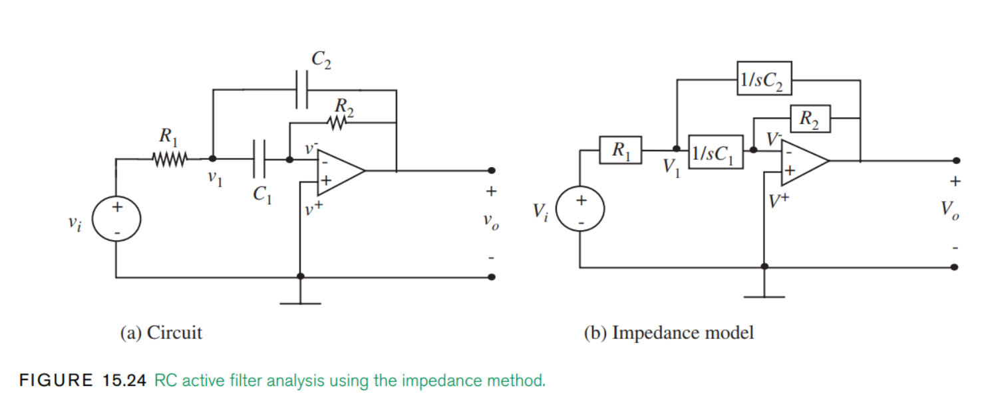

Figure.2. Second-order RC active filter

In the textbook, this circuit has been analyzed using two different approaches. Here, I derive the transfer function in a slightly different manner using our op-amp rules: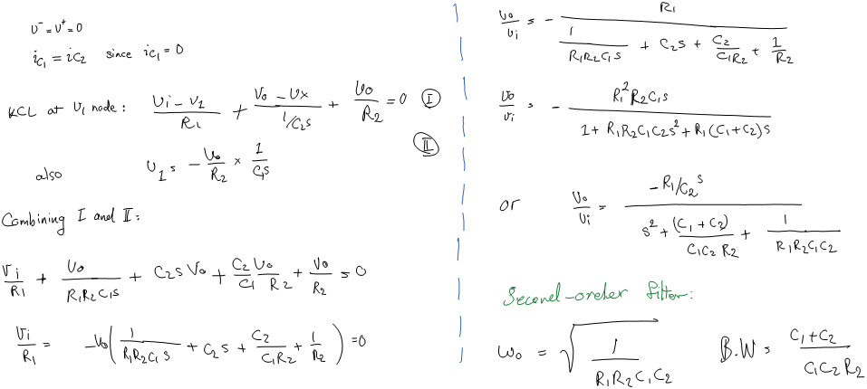

Notice that we now have a second-order filter without the presence of any inductors! This is a huge selling point of active filters. Inductors are hard to miniaturize (can't be integrated with VSLI!), expensive, and can even cause interference on the chip. Also, in the previous labs, we experienced that filters with inductors can hardly function at low frequencies because of their high input resistance. Therefore low-frequency filters are mostly implemented using active filters in the industry. Finally, note that we could build a second-order filter using resistors and capacitors only because we mathematically relied on the feedback loop of the op-amp.

**Step-1: Desing of Sallen-key low-pass filters**

The addition of the op-amp and its feedback loop to our passive elements extends the design space of filters tremendously. There are many avaiable active-filter topologies such like multiple-feedback, wien notch, sallen-key filters, butterworth filters, and etc. In this lab, we will focus on the Sallen-Key filter topology.

Sallen-Key filters are a subset of VCVS (Voltage-controller voltage-source) filters that have infinite input impedance, zero output impedance, and can implement low/high/bandpass/band-stop filters with high Q and gain without any inductors. These properties have made Sallen-Key filters a standard topology in active-filter design.

Let's dive in.

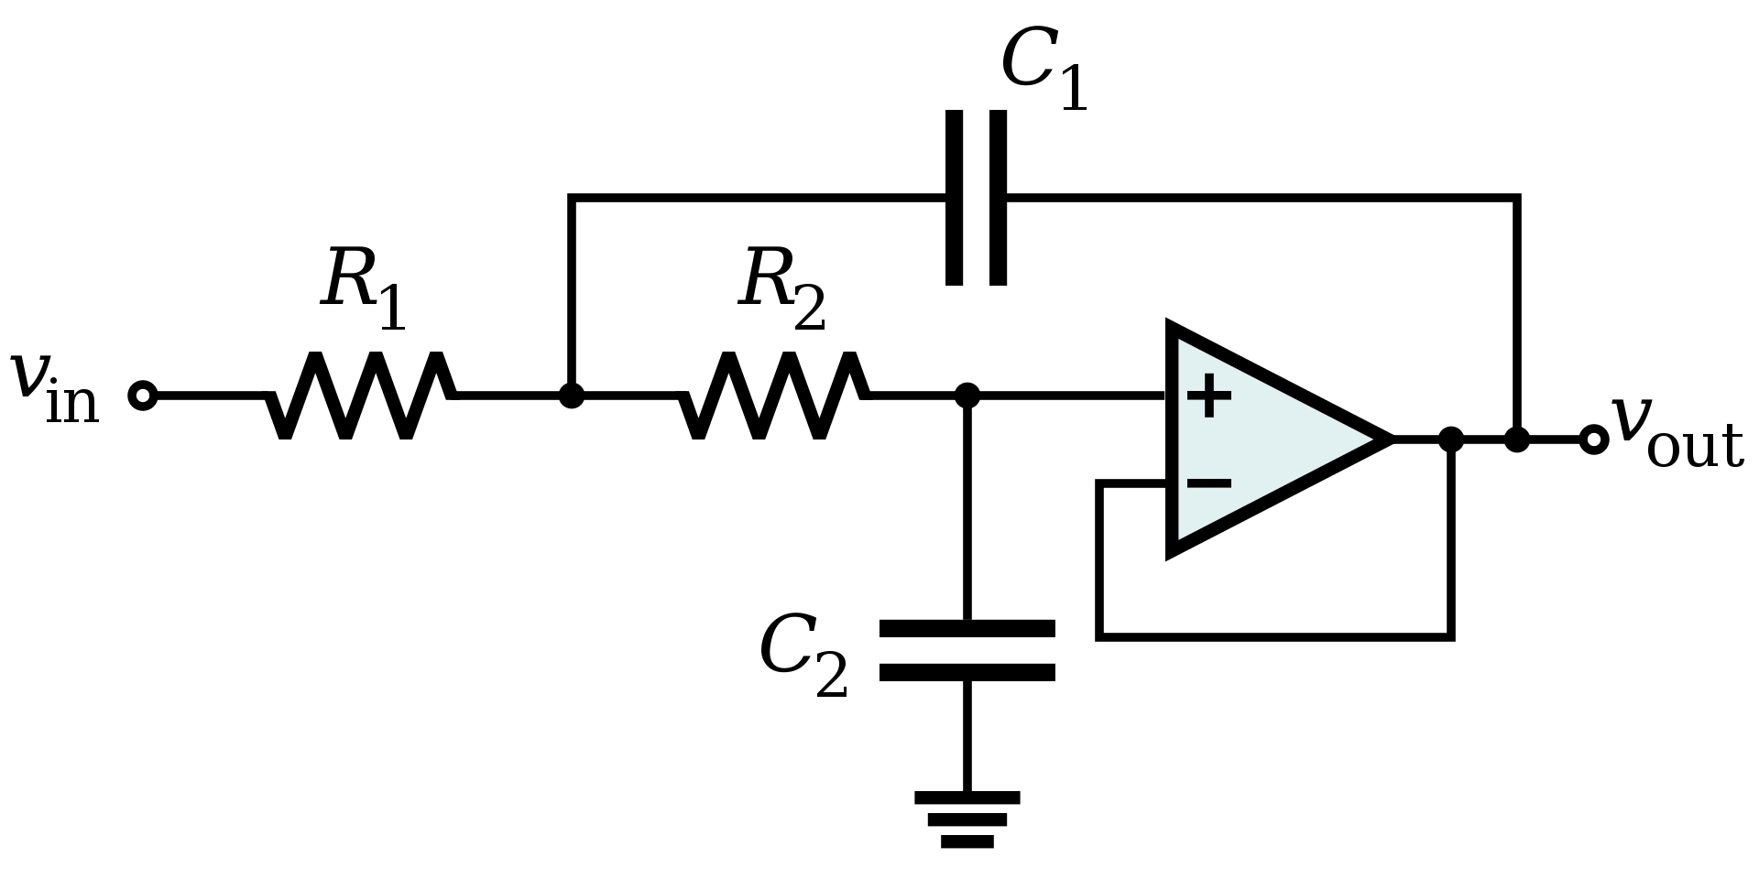

Figure.3. Sallen-key low-pass filter

* Using the op-amp laws, following the last two examples, derive the transfer function of the following Sallen-Key low pass filter.
* Determine the resonance frequency and quality factor of the filter.
* Design a low-pass active filter with a resonant frequency of 7 hz and Q= 0.707. Because there are multiple parameters for this design, it is good practice to fix the resistor values and set the capacitors to be multiples of one another. For example, let R1 = R2 = R and C2 = mC1 , and solve for the value of ​m that leads to the desired ​Q​-value. Let C1 = 100uF and choose the value of R​ that satisfies the resonance frequency ​f​0​.
* Draw the bode plot of the filter.

**Step.2: Experimental implementation of low-pass Sallen-Key Filter**

Let's go back to last week's circuit implementation. We will only use the first two-stages at the moment. Let's feed our noisy signal from lab-5 to our new low-pass Sallen-key design to isolate our ~1.5 Hz frequency component. Use C1= 100uF, C2= 47uF, and resistors you calculated from the design part to build the circuit.

* Scope/plot the output and confirm your filter is working.
* Compared to a simple RC circuit with the same cut-off frequency, explain why your current design performs better at suppressing the 16hz component.
* Bonus question: How would you change/modify this design to enhance the suppression of the 16hz component while compensating for the loss of the 1.5 Hz component?



Figure.4. Sallen-key low-pass filter implementation

**Step.3: Sallen-key resonant bandpass filter design**

We learned in class that a second-order low-pass/high-pass filter could also function as a resonant bandpass filter if the quality factor of the filter is set high enough. Let's configure the same Sallen-Key topology to now function as a resonant bandpass filter and filter-out the 16hz component again.

1. Knowing that the 16hz mid-frequency component is about 14 Hz apart from the low-frequency component. Find the minimum Q factor needed for resonant bandpass design.
2. For a better design, let's go with a quality factor value of 3. Similar to step-1, assuming R1 = R2 = R and C2 = mC1. Calculate R and m given C1=100uF
3. Draw the bode plot of your filter. Denote max gain, bandwidth, cut-off (resonance), and the slopes.

**Step.4: Sallen-key resonant bandpass filter implementation. The final test!**

* Using the components you have, you can now implement a resonant bandpass filter design similar to step-3 (you are not limited to C1=100uF). Implement a Salley-key resonant bandpass filter that is in resonance with your ~16hz component signal.
* Draw/plot the bode plot of your design. Denote max gain, bandwidth, cut-off (resonance), and the slopes.
* Scope and plot the output. Plot both your noisy signal and your output signal. A correct design must achieve the above unity gain on the 16hz component.
* You will notice that your low-frequency component is still sensible. This is because even though you have amplified your 16hz signal component, your low-frequency component is also being passed with a gain larger than 1. Can you think of a way to remove the low-frequency response without requiring an additional high-pass filter?

**Hints:**

1. Your design process is very similar to step.3. You only have to modify/choose values close to components you have (This [link](http://sim.okawa-denshi.jp/en/OPseikiLowkeisan.htm) will help you out). I suggest using Q factor above 3. However, don't use too large Q's since as your Q increases, your bandwidth would decrease, which means finding the appropriate resistors that can bring the system into resonance becomes more difficult.
2. The mid component frequency is not precisely at 16 Hz. So I would suggest trying to fine-tune the final R1 and R2 resistors by increasing/decreasing them to see when you would reach the resonance condition.